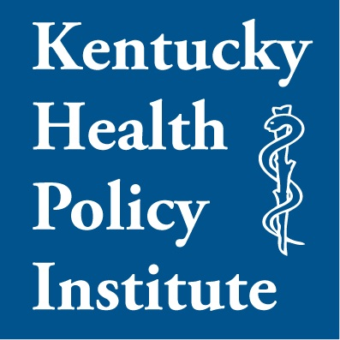
7 Dec 2011

Governor Steve Beshear
700 Capitol Avenue, Suite 100
Frankfort, Kentucky 40601

Re: Premature approval of hospital acquisition in Louisville.

Dear Governor Beshear,

You have been asked to consider approving a merger/acquisition involving the University of Louisville and University Hospital, Jewish Hospital & St. Mary's, and the St. Joseph's Hospital System under the auspices of Catholic Health Initiatives. Individuals and Organizations (including women's organizations) in the Louisville Community who have written or spoken about this matter are overwhelmingly against this merger, save for employees of the University, or its business partners. The opposition continues unabated despite several public and private briefings. This is in great measure because of the puzzling refusal of the proposal advocates to disclose relevant details supporting the real public or indigent-care need for the merger, or the implementation of its most controversial elements– especially those revolving around church and state issues.

The Louisville Board of Health "was unable to draw a definitive conclusion regarding the extent to which the stated rationale for the merger is supported." Aligning a public university with a single religion will fundamentally change its relationship with the Commonwealth and its ability to benefit from that relationship. Surely there is no anti-trust justification prohibiting the University from revealing the contract terms they have agreed to (today and in perpetuity) over which, if any, of the Catholic Ethical and Religious Directives they will follow, or the role of local bishops in determining ongoing business and clinical operations of the hospital. It is already clear that the University has given away some of its independence. It is far from clear that it is necessary for University to merge with other hospitals in order to continue providing its share of indigent care, especially since University Hospital’s own profits are rising, its excess profit is being given to the University of Louisville, and that none of the new money promised by CHI will be used for medical care of the indigent. I have begun to address some of the relevant issues on the KHPI Health Policy Blog.

The University and its Hospital have defied the Attorney General, and the Jefferson County Attorney in refusing to release relevant records. The whole issue of whether University Hospital is a private or public institution is still unresolved and in the courts. The public is waiting for reports from the Attorney General and State Auditor. One is forced to wonder what the merger players have to hide if their claim is to be acting in the public interest. In the wake of the Passport and other scandals, "Trust Us" is not an appropriate answer. The appropriate posture is "Trust but Verify." You should demand public disclosure just as you have done for the Children's Protective Service of your Cabinet.

I had been content to wait for the above reports and the results of the processes of the courts. However, I have heard "on the street" that your approval of the merger/acquisition may be imminent before the additional information is available to the citizens of Kentucky. A precipitous closing of the deal would make the concerns above and others moot.

I urge you not to do this. I believe it would destroy the integrity of the process and lead to unnecessary ongoing dispute and lawsuits that will benefit no one. No one should be able to claim that this deal favored the politically connected. I believe you can preserve the integrity of the process by resisting pressure to approve the process prematurely.

Respectfully,

Peter Hasselbacher, MD
President,
Kentucky Health Policy Institute
http://www.khpi.org/blog

